EXPERIMENT 13: - Create a Virtual Hard Disk and allocate the storage using VM ware

Workstation.

Step 1: - Install VM Ware PlayStation

Step 2: - Create new virtual machine

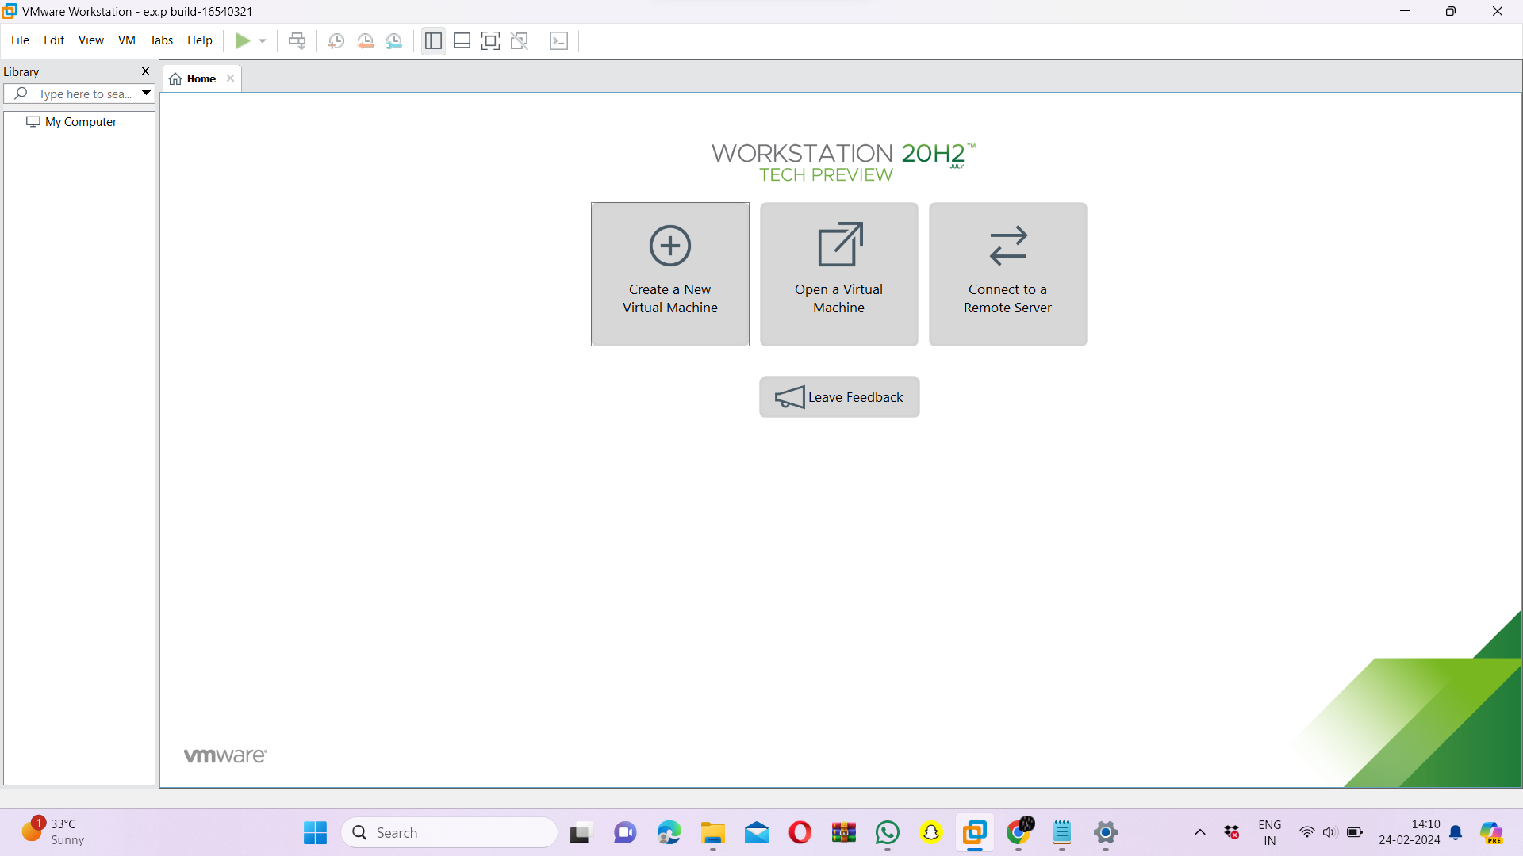

Step 3: - Choose Typical option and click Next

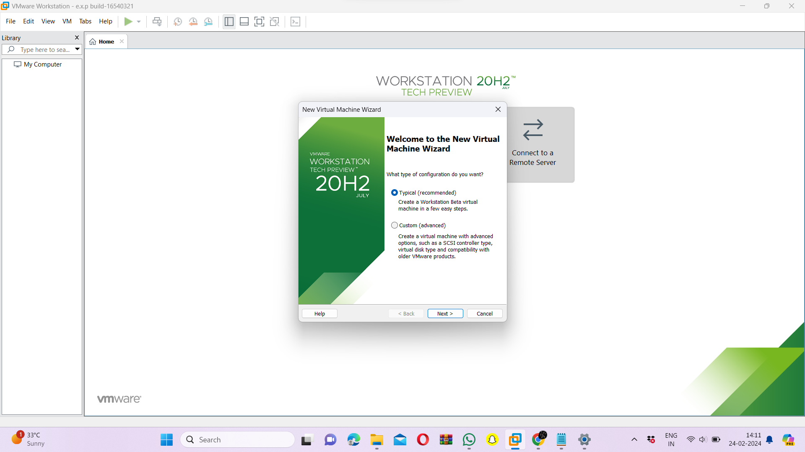

Step 4: - Click on the third option at guest os screen

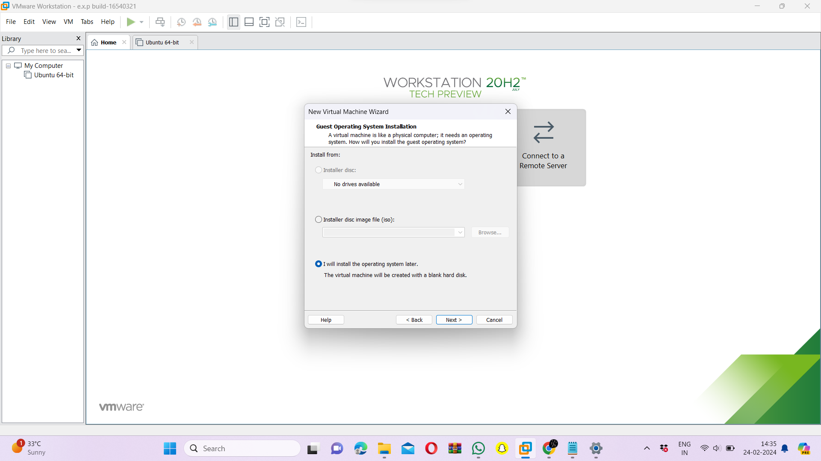

Step 5: - Choose the required os and click next

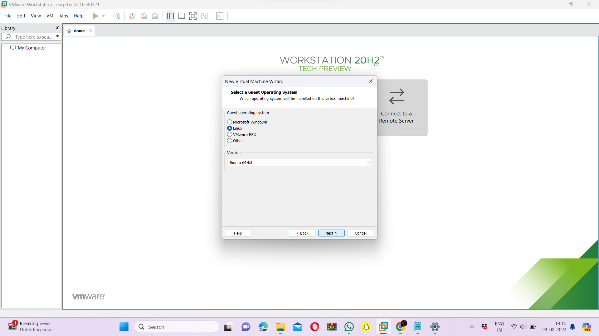

Step 6: - Enter the name of the virtual machine

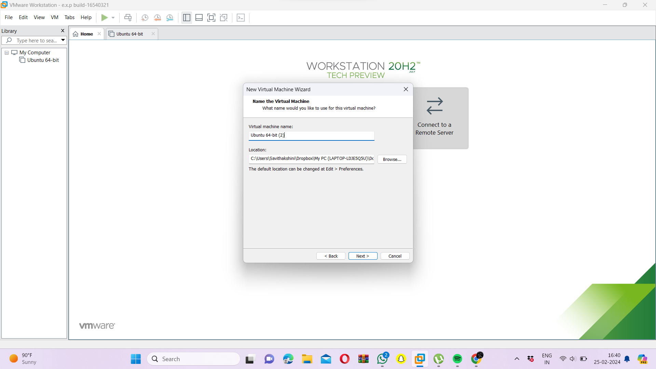

Step 7: - Edit the disk space and click next

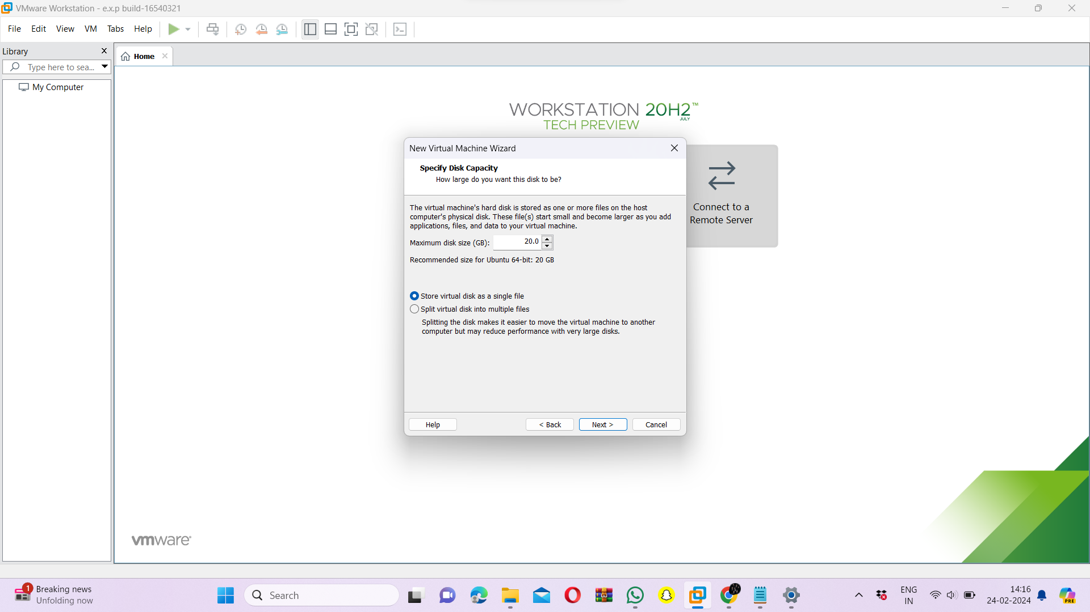

Step 8: - Check the summary and click next

Step 9: - Edit the virtual machine settings and add a new hard disk and click next

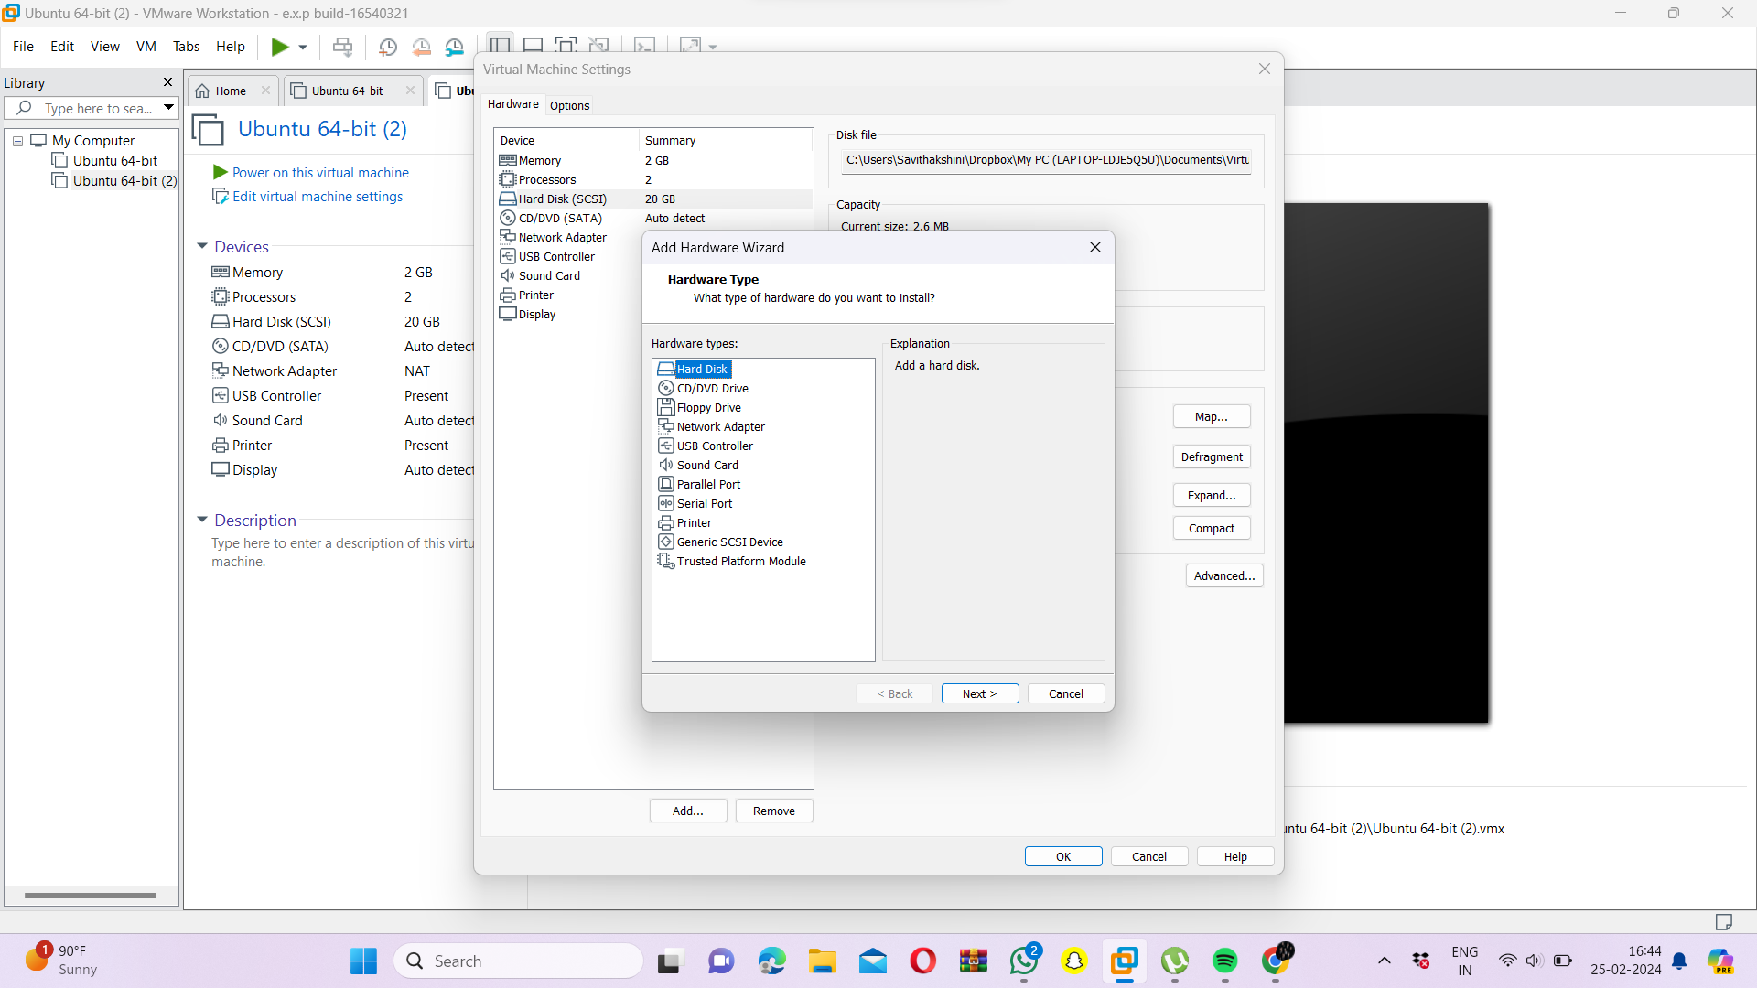

Step 10: - New hard disk has been added successfully.

